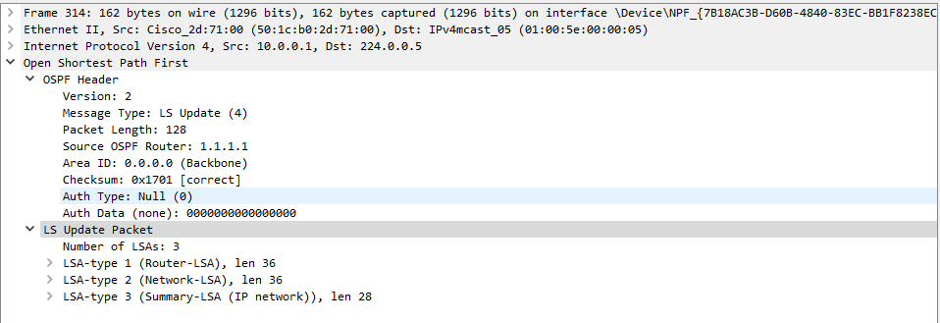**LSA Types:**

Type 1) Router

-List of directly connected links from each router

-Always stays within one area

-Generated by each router within an area

-Shows as “O” route type

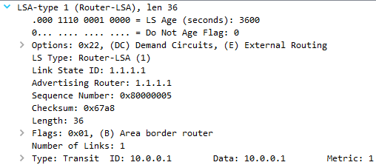

Type 2) Network

-Used for multiaccess networks

-Always stays within the area

-Generated by each area DR

-Shows as “O” route type

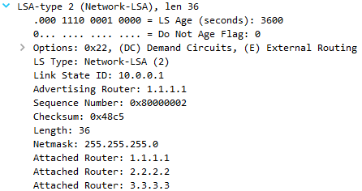

Type 3) Summary

-Used to flood information about network to other external areas

-Advertised by the ABR router (interarea router)

-Shown as “O IA”

-Propagated across networks

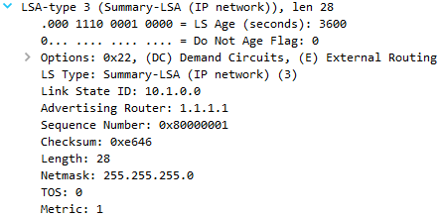

Type 4) Summary ASBR

-Same as type 3, but is used for networks with an ASBR

-Advertised by the ABR of each area

-Includes info about the ASBR to other areas, and how to reach it

-Shown as “O IA”

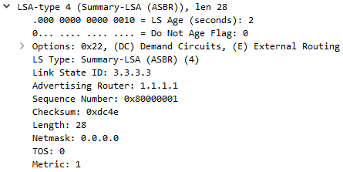

Type 5) AS external

-Still requires a type 4 to locate where the ASBR is

-Shown as “O E1/E2”

-Incudes info about external routes propagated from different routing protocols outside of OSPF

-Distributes that information to the network

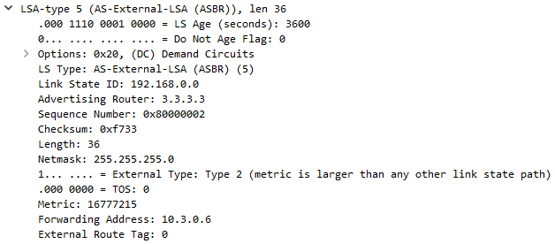

Type 7) NSSA

-Type 5 not allowed in NSSA, so this is the solution

-Not blocked in the NSSA, but carries similar info to Type 5

-Shown as “O N1/N2”

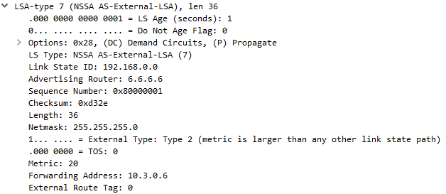

**Stub**

-Single exit point

-Blocks type 5/7 LSA

-To configure, use “area # stub” in OSPF config on the ABR

-Helps with consumption of CPU and bandwidth of router, because less LSA’s are sent/received

-Default route is injected in order to reach external network

-All routers have to be stub in the area

**Totally Stub**

-Doesn’t accept external routes

-Reduces size of routing table

-There is only a default route used

-Helps with consumption of CPU and bandwidth even further

-All routers have to be stub, and the ABR has to be totally stubby

-To configure, stub on all routers and use “area # stub no-summary” on the ABR

**NSSA**

-ASBR advertises external links via ABR

-Conversion of type 7 into type 5

-To configure, NSSA on all routers using “area # nssa”